

Sprint 2 Submission Plan – Hospital Management System

Full Name | ID No:
Tharun Kumar | A00085282
Sai Krishna | A00083489
Mani | A00049148
Akhilesh | A00085933
Mohan | A00037737

Table of Contents

1. User Stories 2
2. User Stories Tracking using Task Board 3
3. Wireframes 5
4. User Flow or Activity Diagrams 9
5. UML Diagrams 13
6. Customer Journey Map 17

1. User Stories

Role | User Story
Administrator | As an admin, I want to add new staff members so that they can access the HMS.
Administrator | As an admin, I want to view all appointments so that I can monitor hospital schedules.
Administrator | As an admin, I want to generate monthly reports to analyze hospital performance.

Role | User Story
Doctor | As a doctor, I want to view a patient’s medical history so that I can make informed decisions.
Doctor | As a doctor, I want to update patient records so that treatment details are always current.
Doctor | As a doctor, I want to manage my appointment schedule so that I can avoid conflicts.

Role | User Story
Receptionist | As a receptionist, I want to register patients quickly so that waiting times are minimized.
Receptionist | As a receptionist, I want to schedule appointments so that patient flow is organized.
Receptionist | As a receptionist, I want to generate invoices for patients so that billing is accurate.

Role | User Story
Patient | As a patient, I want to book appointments online so that I avoid queues.
Patient | As a patient, I want to view my medical records so that I can track my health.
Patient | As a patient, I want to pay bills online so that payments are convenient.

2. User Stories Tracking using Task Board
Link - https://sharing.clickup.com/90152351755/b/h/6-901520945601-2/b92ae35bd5e77fb
- Track your user stories in your Kanban board / task board.
- Columns: User Stories → To Do → In Progress → Completed.
- Assign each story to a team member with estimated completion time.

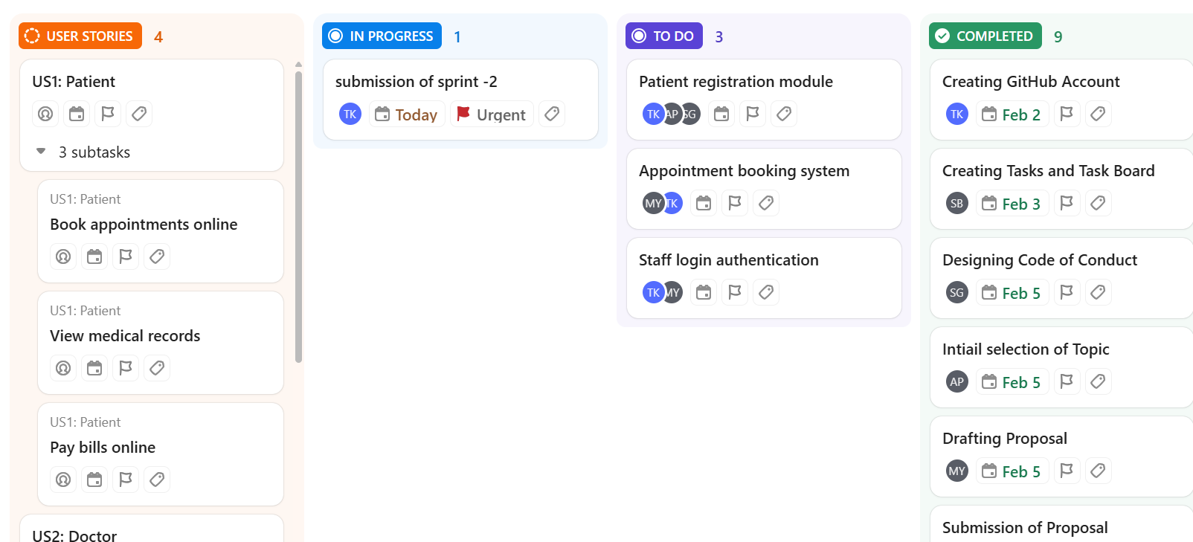

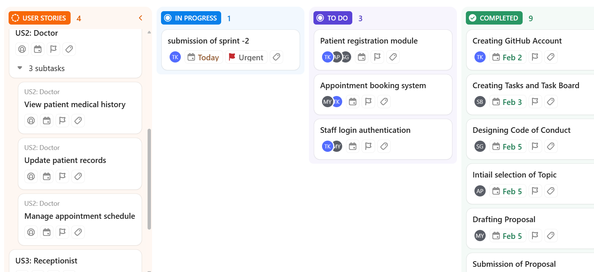

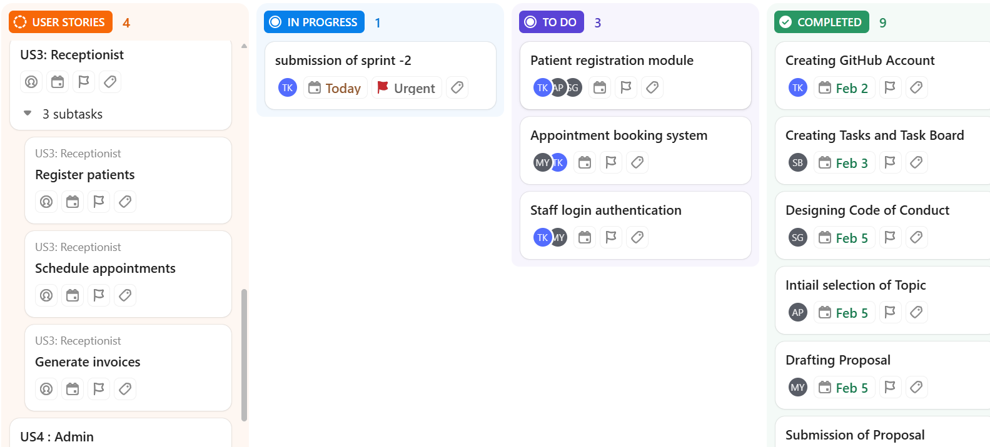

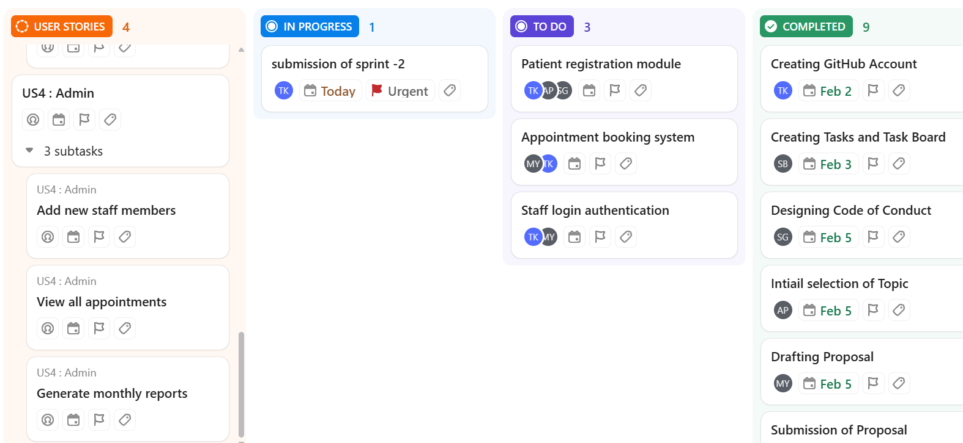

3. Wireframes
1. Login / Register Page
This page allows users to securely log in or create a new account. Patients and doctors can choose their user type while registering. It provides input fields for credentials and authentication actions. Links for password recovery and app policies are also included.

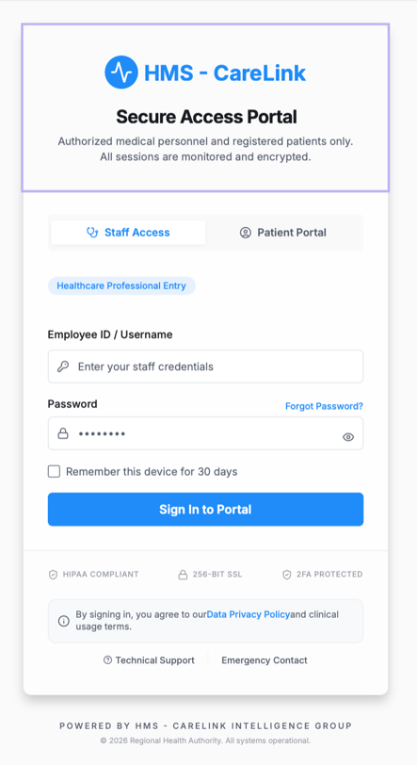

2. Patient Dashboard
The patient dashboard serves as the main hub for patients to view appointments and notifications. It provides quick access to book doctors and review medical history. Upcoming appointments are displayed prominently for easy tracking. Additional health tips or messages may also be shown.

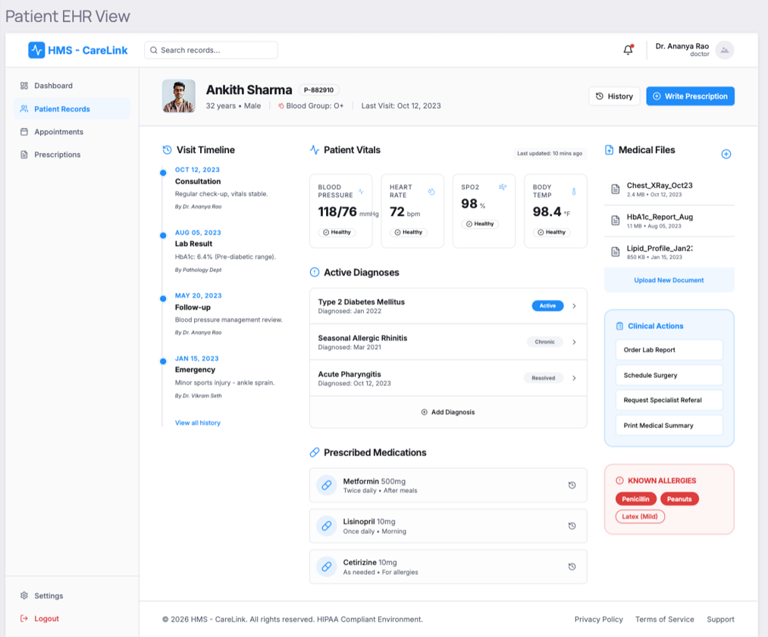

3. Doctor Dashboard
The doctor dashboard allows doctors to manage their schedule and patient interactions efficiently. It shows today’s appointments, pending requests, and patient statistics. Quick actions to approve or reschedule appointments are available. Notifications and messages are highlighted for timely updates.
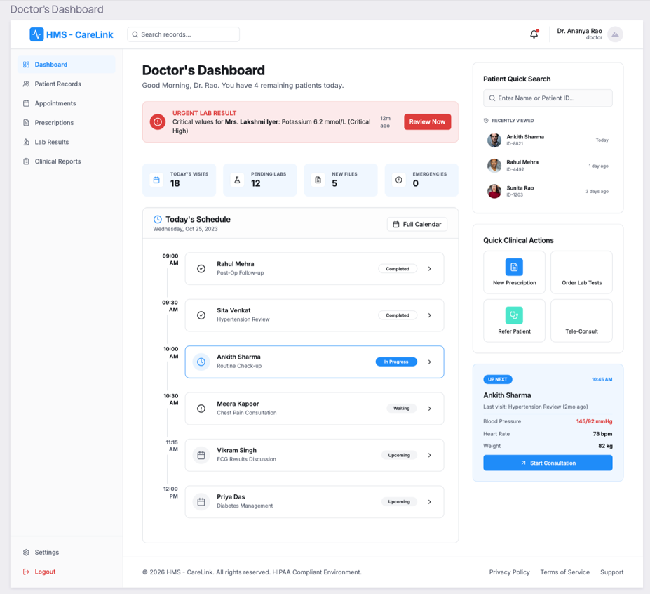

4. Appointments & Bookings Dashboard
This dashboard centralizes all appointment management for patients and doctors. It provides calendar and list views of scheduled bookings with statuses. Users can filter, search, and perform actions like approve, cancel, or reschedule appointments. It ensures organized and streamlined scheduling management.

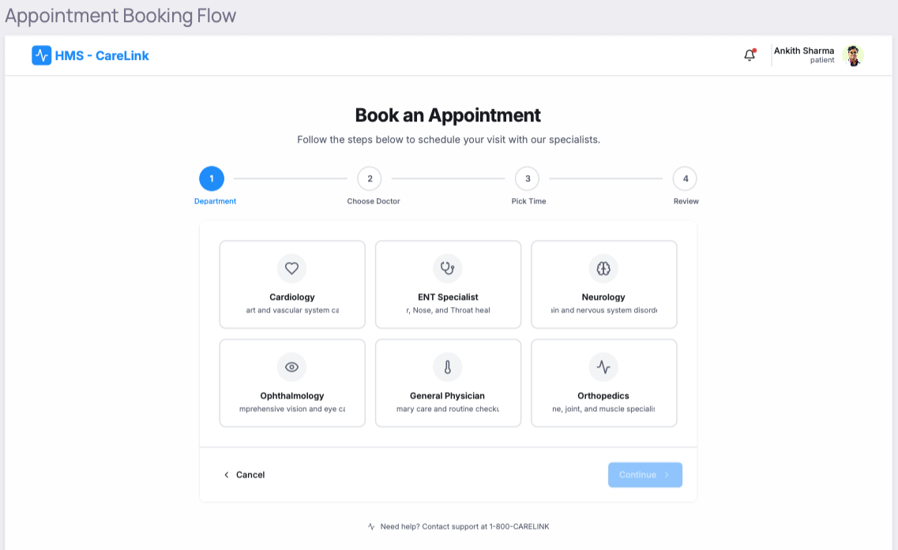

4. User Flow or Activity Diagrams
Doctor
The doctor logs in and opens their dashboard to view today’s schedule. They manage appointment requests by approving, rejecting, or rescheduling them and can check detailed appointment information. Doctors can access patient lists and medical records, view and respond to messages, and update their profile or availability.

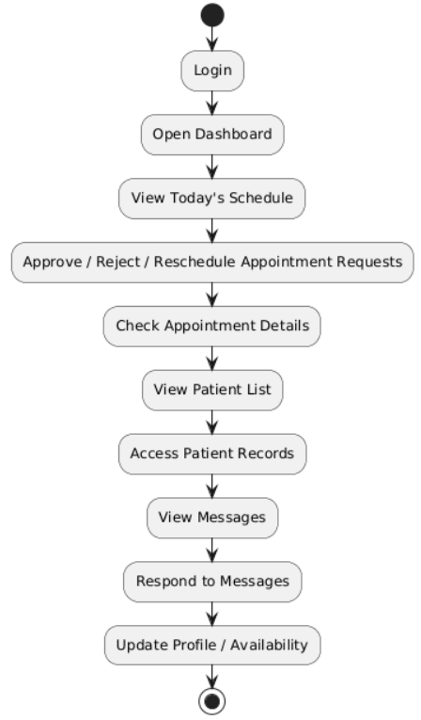

Patient
The patient logs in or registers to access their dashboard. They can view upcoming appointments, book new ones, or cancel/reschedule existing appointments. Patients can also review their medical history, access reports or prescriptions, and receive notifications or messages. Finally, they can update their profile and account settings.

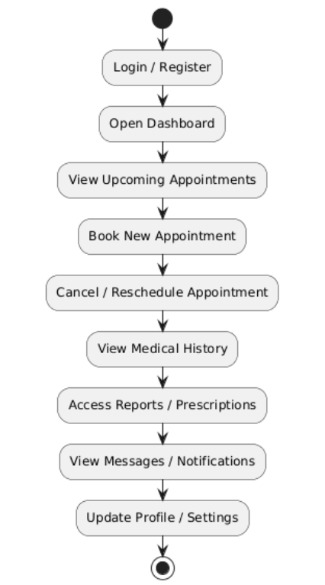

Receptionist
The receptionist logs in and accesses the dashboard to manage doctors’ schedules. They create, reschedule, or cancel appointments for patients and update patient records as needed. Receptionists also notify patients about their appointments, generate reports or analytics, and update their profile or account settings.
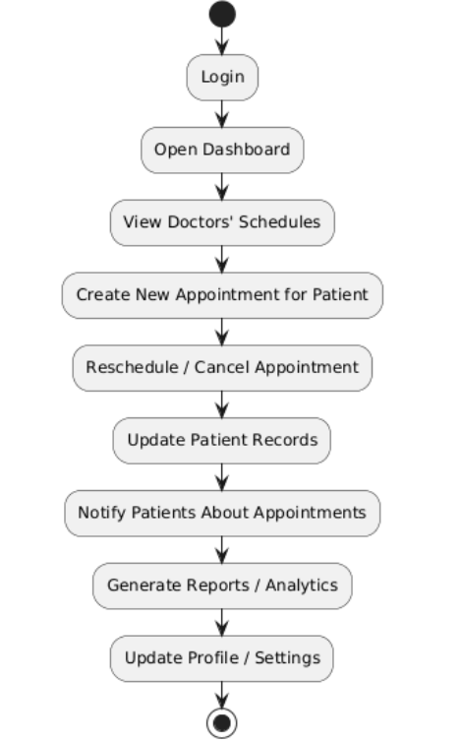

5. UML Diagrams
Use Case Diagram:
The use case diagram illustrates the roles of Admin, Doctor, Receptionist, and Patient. It shows how each interacts with the HMS features. Admin manages users and system settings. Doctors handle appointments and patient records. Receptionists and patients interact through bookings, notifications, and medical history.

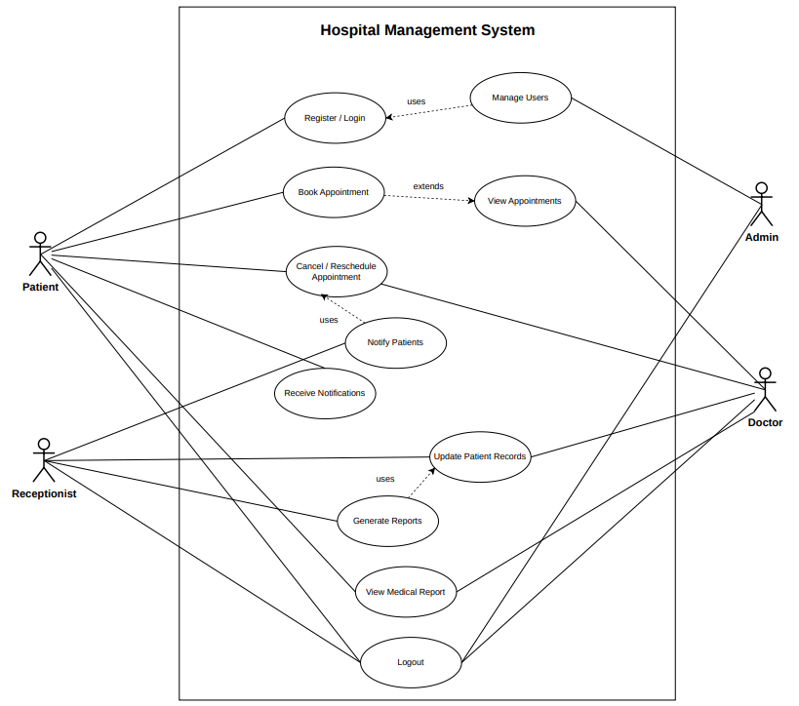

Class Diagram:
The class diagram represents core HMS entities such as Patient, Doctor, Appointment, Billing, and MedicalRecord. It shows attributes and methods for each class. Relationships between entities are highlighted, e.g., Patient → Appointment → Billing. Inheritance is used where applicable. The diagram provides a blueprint of system structure.

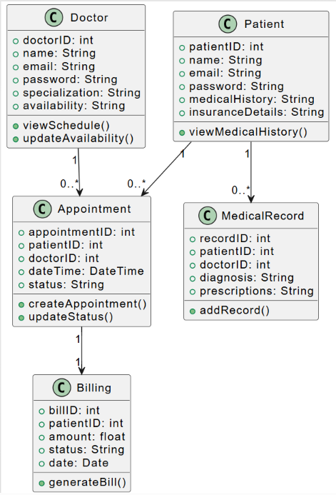

State Diagram:
The state diagram tracks the lifecycle of an appointment. It starts from Scheduled, moves to Completed, then Billed, and finally Closed. Cancellations are also captured as a transition. It visually represents how appointment states change over time. This helps in understanding workflow and system behaviour.

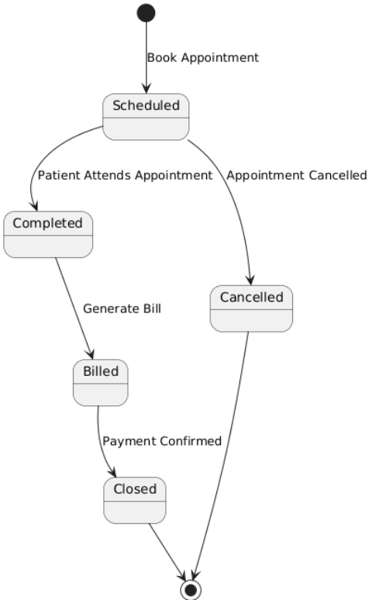

Sequence Diagram:
The sequence diagram shows step-by-step interactions when a patient books an appointment. It involves Patient, Receptionist, and Doctor as participants. The flow covers requesting, confirming, creating records, and sending notifications. It highlights the order of messages between participants. The diagram ensures clarity in system operations.

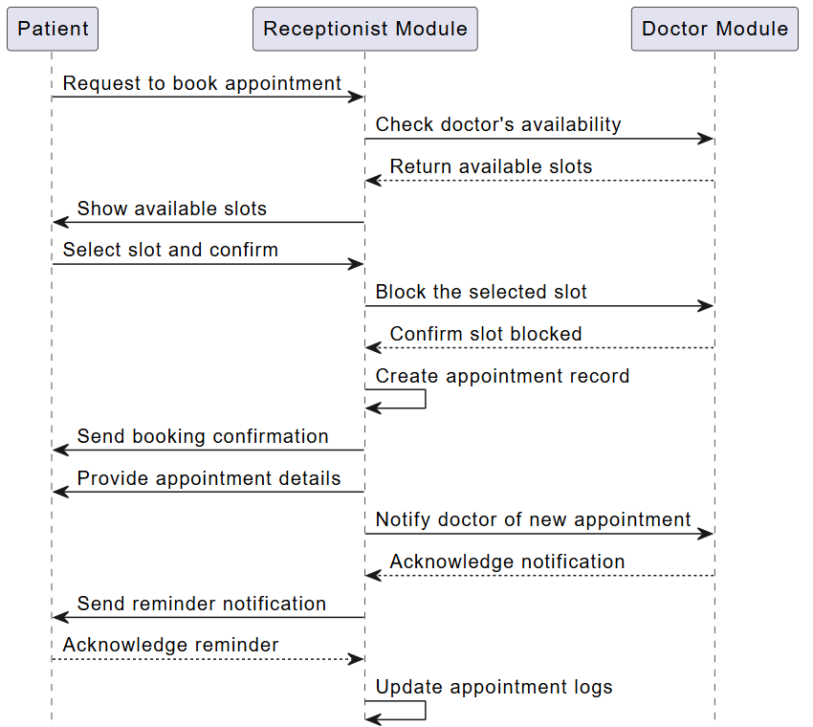

6. Customer Journey Map
The user journey map illustrates the patient experience within the Hospital Management System, covering stages from researching hospital services to post-treatment follow-up. It highlights emotional variations during appointment booking, approval delays, consultation, and recovery, while identifying improvement opportunities such as streamlined processes, reduced waiting times, enhanced onboarding support, and improved patient engagement.
